1.0 Introduction
This document contains the locations for all twelve starter Pokemon and all thirty-five legendaries. Every single one of these (aside from those which are starters at Elm’s lab and a gift from Oak/Steven) is displayed as an overworld sprite on the map listed, and are not found in the grass/cave/whatever else.

INDEX | SECTION
1.1 | Starter Locations
1.2 | Special Pokémon Locations
1.3 | Legendary Locations

1.1 Starter Locations

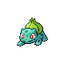 | 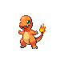 | 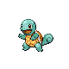
Bulbasaur | Charmander | Squirtle
Level 15 | Level 15 | Level 15
Ilex Forest (L15)  Oak’s Lab (L5) | Route 33 (L10)  Oak’s Lab (L5) | Slowpoke Well (L10)  Oak’s Lab (L5)
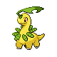 | 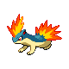 | 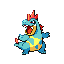
Bayleef | Quilava | Croconaw
Level 24 | Level 24 | Level 24
Route 37 | Burned Tower 1F | Route 42
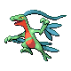 | 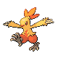 | 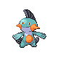
Grovyle | Combusken | Marshtomp
Level 34 | Level 34 | Level 34
Starter (Treecko)  Route 44  Silph Co (Treecko) | Starter (Torchic)  Route 45  Silph Co (Torchic) | Starter (Mudkip)  Ice Path B4F  Silph Co (Mudkip)
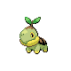 | 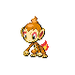 | 
Turtwig | Chimchar | Piplup
Level 12 | Level 12 | Level 12
Violet City | Dark Cave | Ruins of Alph Outside

1.2 Special Pokémon Locations
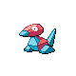 | 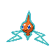 | 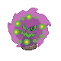
Porygon | Rotom | Spiritomb
Level 18 | Level 33 | Level 42
Goldenrod Underground B1F | Goldenrod City Dept. Store B1F | Victory Road 1F

1.3 Legendary Locations

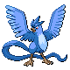 | 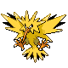 |  | 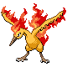 |  | 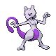
Articuno | Zapdos |  | Moltres |  | Mewtwo
Level 60 | Level 60 |  | Level 60 |  | Level 75
Seafoam Islands B4F | Route 10 (after 16 badges) |  | Mt. Silver Back Room |  | Cerulean Cave B2F
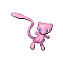 | 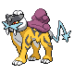 |  | 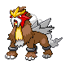 |  | 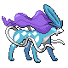
Mew | Raikou |  | Entei |  | Suicune
Level 30 | Level 40 |  | Level 40 |  | Level 40
Ruins of Alph Outside | Burned Tower  Roaming |  | Burned Tower  Roaming |  | Route 25 / Burned Tower
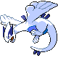 | 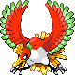 |  |  |  | 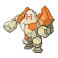
Lugia | Ho-oh |  | Celebi |  | Regirock
Level 70 | Level 45 |  | Level 30 |  | Level 60
Whirl Islands B4F | Bell Tower Rooftop |  | Ilex Forest (Surf) |  | Mt. Silver 1F
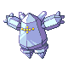 | 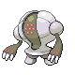 |  | 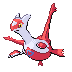 |  | 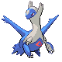
Regice | Registeel |  | Latias |  | Latios
Level 60 | Level 60 |  | Level 35 |  | Level 45
Mt. Silver Snowy Area | Mt. Silver 2F |  | Roaming Kanto |  | Route 47 (Waterfall)
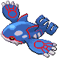 | 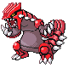 |  | 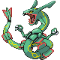 |  | 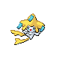
Kyogre | Groudon |  | Rayquaza |  | Jirachi
Level 70 | Level 70 |  | Level 70 |  | Level 30
Embedded Tower | Embedded Tower |  | Embedded Tower |  | Bell Tower 7F
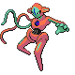 | 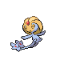 |  | 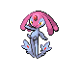 |  | 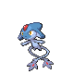
Deoxys | Uxie |  | Mesprit |  | Azelf
Level 60 | Level 60 |  | Level 60 |  | Level 60
Route 3 | Route 21 |  | Route 13 |  | Route 19
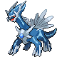 | 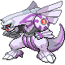 |  | 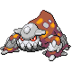 |  | 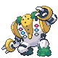
Dialga | Palkia |  | Heatran |  | Regigigas
Level 70 | Level 70 |  | Level 70 |  | Level 70
Embedded Tower | Embedded Tower |  | Cinnabar Island (Crater) |  | Mt. Silver 3F
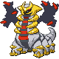 | 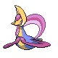 |  |  |  | 
Giratina | Cresselia |  | Phione |  | Manaphy
Level 70 | Level 60 |  | N/A |  | Level 30
Embedded Tower | Mt. Moon Outside* |  | Breed Manaphy |  | Whirl Islands B1F
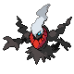 |  | 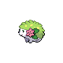 |  | 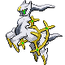
Darkrai |  | Shaymin** |  | Arceus
Level 70 |  | Level 30 |  | Level 80
Cerulean Cave B1F |  | National Park (Rock Climb) |  | Mt. Silver 3F

* Cresselia is only there on Monday nights, when the Clefairy are present.

** Note that as this is not a fateful encounter Shaymin, you will be unable to either obtain the Gracidea with it or use the Gracidea on it. Sky Forme is only possible with fateful encounter Shaymin, so you must trade from another game if you wish to use the Sky Forme.

